Check If Your Feces are Healthy!!!
Dietary figers and lactobacillus bifidus are essental for healthy and comfortable life. The best feces are like bananas. They are modestly hard with no strong smell. Feces are a barometer of your health and beauty. Check the following questions to see if you have healthy feces or not.
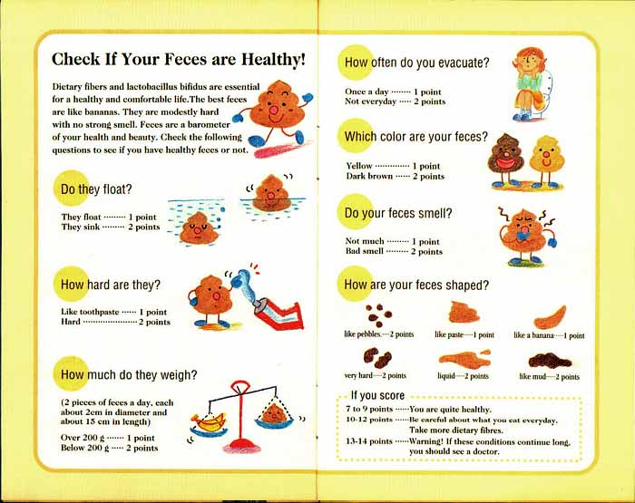
IF YOU SCORE…
7 to 9 points…You are quite healthy.
10 to 12 points…Be careful about what you eat everyday. Take more dietary fibers.
13 to 14 points…WARNING!!! If these conditions continue long, you should see a doctor.

